Experiment No.7

Date:11.03.25

Aim: Implementation of real world problem based on servlet concept

CO Mapping – CO 3

Objective:

1. To write servlet programs
2. To connect servlet programs with the help of JSP with database

Code:

**pom.xml**

<project xmlns="http://maven.apache.org/POM/4.0.0" xmlns:xsi="http://www.w3.org/2001/XMLSchema-instance"  
 xsi:schemaLocation="http://maven.apache.org/POM/4.0.0 http://maven.apache.org/maven-v4_0_0.xsd">  
 <modelVersion>4.0.0</modelVersion>  
 <groupId>org.example</groupId>  
 <artifactId>servlet_withDB</artifactId>  
 <packaging>war</packaging>  
 <version>1.0-SNAPSHOT</version>  
 <name>servlet_withDB Maven Webapp</name>  
 <url>http://maven.apache.org</url>  
 <dependencies>  
 <dependency>  
 <groupId>junit</groupId>  
 <artifactId>junit</artifactId>  
 <version>3.8.1</version>  
 <scope>test</scope>  
 </dependency>  
 <dependency>  
 <groupId>javax.servlet</groupId>  
 <artifactId>javax.servlet-api</artifactId>  
 <version>4.0.1</version>  
 <scope>provided</scope>  
 </dependency>  
 <dependency>  
 <groupId>com.mysql</groupId>  
 <artifactId>mysql-connector-j</artifactId>  
 <version>8.0.33</version>  
 <scope>compile</scope>  
 </dependency>  
 </dependencies>  
 <build>  
 <finalName>servlet_withDB</finalName>  
 </build>  
</project>

**RegisterServlet.java**  
package com.example;  
  
import java.io.IOException;  
import java.io.PrintWriter;  
import javax.servlet.ServletException;  
import javax.servlet.http.HttpServlet;  
import javax.servlet.http.HttpServletRequest;  
import javax.servlet.http.HttpServletResponse;  
  
public class RegisterServlet extends HttpServlet {  
 protected void doPost(HttpServletRequest request, HttpServletResponse response)  
 throws ServletException, IOException {  
 response.setContentType("text/html");  
 PrintWriter out = response.getWriter();  
  
 String name = request.getParameter("name");  
 String email = request.getParameter("email");  
 String password = request.getParameter("password");  
  
 boolean success = UserDao.*registerUser*(name, email, password);  
  
 out.println("<!DOCTYPE html>");  
 out.println("<html lang='en'>");  
 out.println("<head><meta charset='UTF-8'><title>Registration</title></head>");  
 out.println("<body style='text-align:center;'>");  
  
 if (success) {  
 out.println("<h2 style='color:green;'>Registration Successful!</h2>");  
 out.println("<p><strong>Name:</strong> " + name + "</p>");  
 out.println("<p><strong>Email:</strong> " + email + "</p>");  
 } else {  
 out.println("<h2 style='color:red;'>Registration Failed!</h2>");  
 out.println("<p>Email already exists or server issue.</p>");  
 }  
 out.println("<a href='index.jsp'>Go Back</a>");  
 out.println("</body></html>");  
 }  
}  
  
  
**DBConnection.java**

package com.example;  
  
import java.sql.Connection;  
import java.sql.DriverManager;  
import java.sql.SQLException;  
  
public class DBConnection {  
 private static final String *URL* = "jdbc:mysql://127.0.0.1:3306/userdb";  
 private static final String *USER* = "root";  
 private static final String *PASSWORD* = "Athanee@08";  
  
 public static Connection getConnection() {  
 Connection conn = null;  
 try {  
 Class.*forName*("com.mysql.cj.jdbc.Driver"); // Ensure driver is loaded  
 conn = DriverManager.*getConnection*(*URL*, *USER*, *PASSWORD*);  
 } catch (ClassNotFoundException e) {  
 System.*out*.println("MySQL JDBC Driver not found!");  
 e.printStackTrace();  
 } catch (SQLException e) {  
 System.*out*.println("Database connection failed!");  
 e.printStackTrace();  
 }  
 return conn;  
 }  
}

**UserDao.java**

package com.example;  
  
import java.sql.Connection;  
import java.sql.PreparedStatement;  
import java.sql.SQLException;  
  
public class UserDao {  
 public static boolean registerUser(String name, String email, String password) {  
 boolean status = false;  
 String query = "INSERT INTO users (name, email, password) VALUES (?, ?, ?)";  
  
 try (Connection conn = DBConnection.*getConnection*();  
 PreparedStatement stmt = conn.prepareStatement(query)) {  
  
 stmt.setString(1, name);  
 stmt.setString(2, email);  
 stmt.setString(3, password);  
  
 int rows = stmt.executeUpdate();  
 status = rows > 0;  
 } catch (SQLException e) {  
 e.printStackTrace();  
 }  
 return status;  
 }  
}

**web.xml**<!DOCTYPE web-app PUBLIC  
 "-//Sun Microsystems, Inc.//DTD Web Application 2.3//EN"  
 "http://java.sun.com/dtd/web-app_2_3.dtd" >  
  
<web-app>  
 <display-name>Archetype Created Web Application</display-name>  
 <servlet>  
 <servlet-name>RegisterServlet</servlet-name>  
 <servlet-class>com.example.RegisterServlet</servlet-class>  
 </servlet>  
  
 <servlet-mapping>  
 <servlet-name>RegisterServlet</servlet-name>  
 <url-pattern>/register</url-pattern>  
 </servlet-mapping>  
  
 <welcome-file-list>  
 <welcome-file>index.jsp</welcome-file>  
 </welcome-file-list>  
</web-app>

**index.jsp**  
<%@ page language="java" contentType="text/html; charset=UTF-8" pageEncoding="UTF-8" %>  
<!DOCTYPE html>  
<html lang="en">  
<head>  
 <meta charset="UTF-8">  
 <meta name="viewport" content="width=device-width, initial-scale=1.0">  
 <title>Registration Page</title>  
 <style>  
 body {  
 font-family: Arial, sans-serif;  
 background: linear-gradient(to right, #00c6ff, #0072ff);  
 display: flex;  
 justify-content: center;  
 align-items: center;  
 height: 100vh;  
 margin: 0;  
 }  
 .container {  
 background: white;  
 padding: 20px;  
 border-radius: 8px;  
 box-shadow: 0px 0px 10px rgba(0, 0, 0, 0.1);  
 width: 340px;  
 text-align: center;  
 }  
 h2 {  
 color: #333;  
 }  
 input {  
 width: 94%;  
 padding: 10px;  
 margin: 10px 0;  
 border: 1px solid #ccc;  
 border-radius: 5px;  
 font-size: 16px;  
 }  
 button {  
 background: #0072ff;  
 color: white;  
 border: none;  
 padding: 10px 15px;  
 cursor: pointer;  
 font-size: 18px;  
 width: 100%;  
 border-radius: 5px;  
 }  
 button:hover {  
 background: #0056d2;  
 }  
 </style>  
</head>  
<body>  
 <div class="container">  
 <h2>Register With Database</h2>  
 <form action="register" method="post">  
 <input type="text" name="name" placeholder="Enter Name" required>  
 <input type="email" name="email" placeholder="Enter Email" required>  
 <input type="password" name="password" placeholder="Enter Password" required>  
 <button type="submit">Register</button>  
 </form>  
 </div>  
</body>  
</html>

Output:

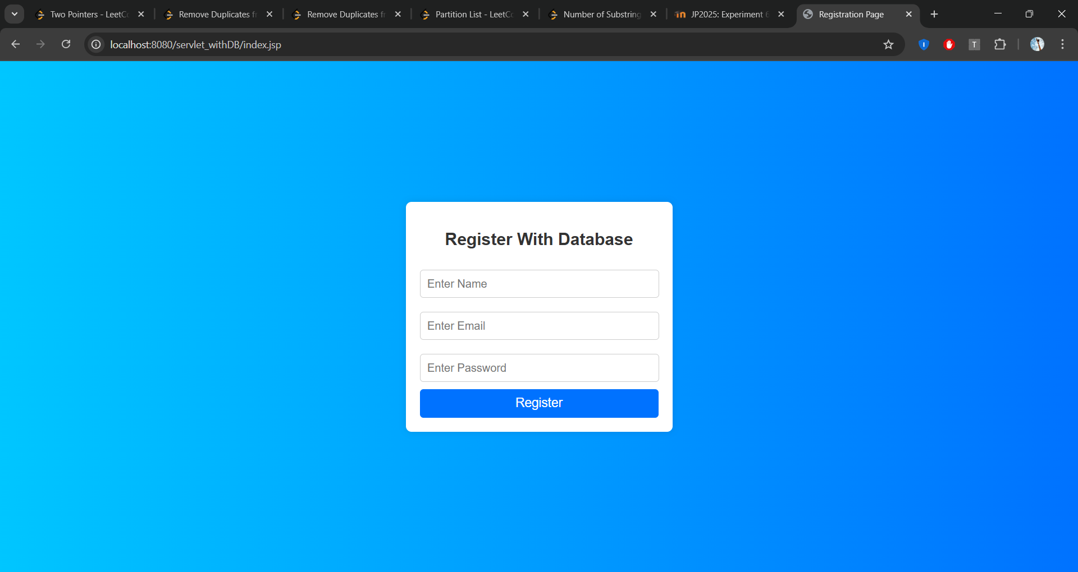

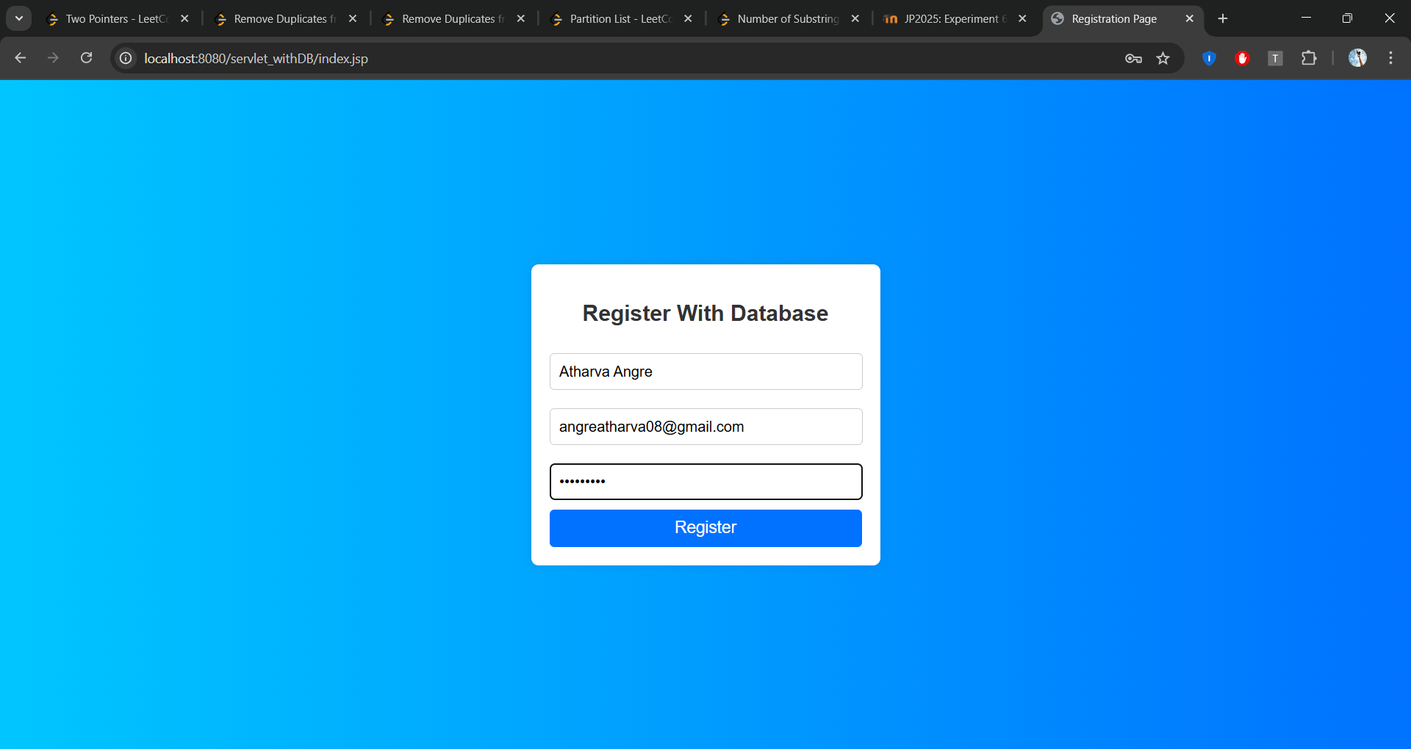

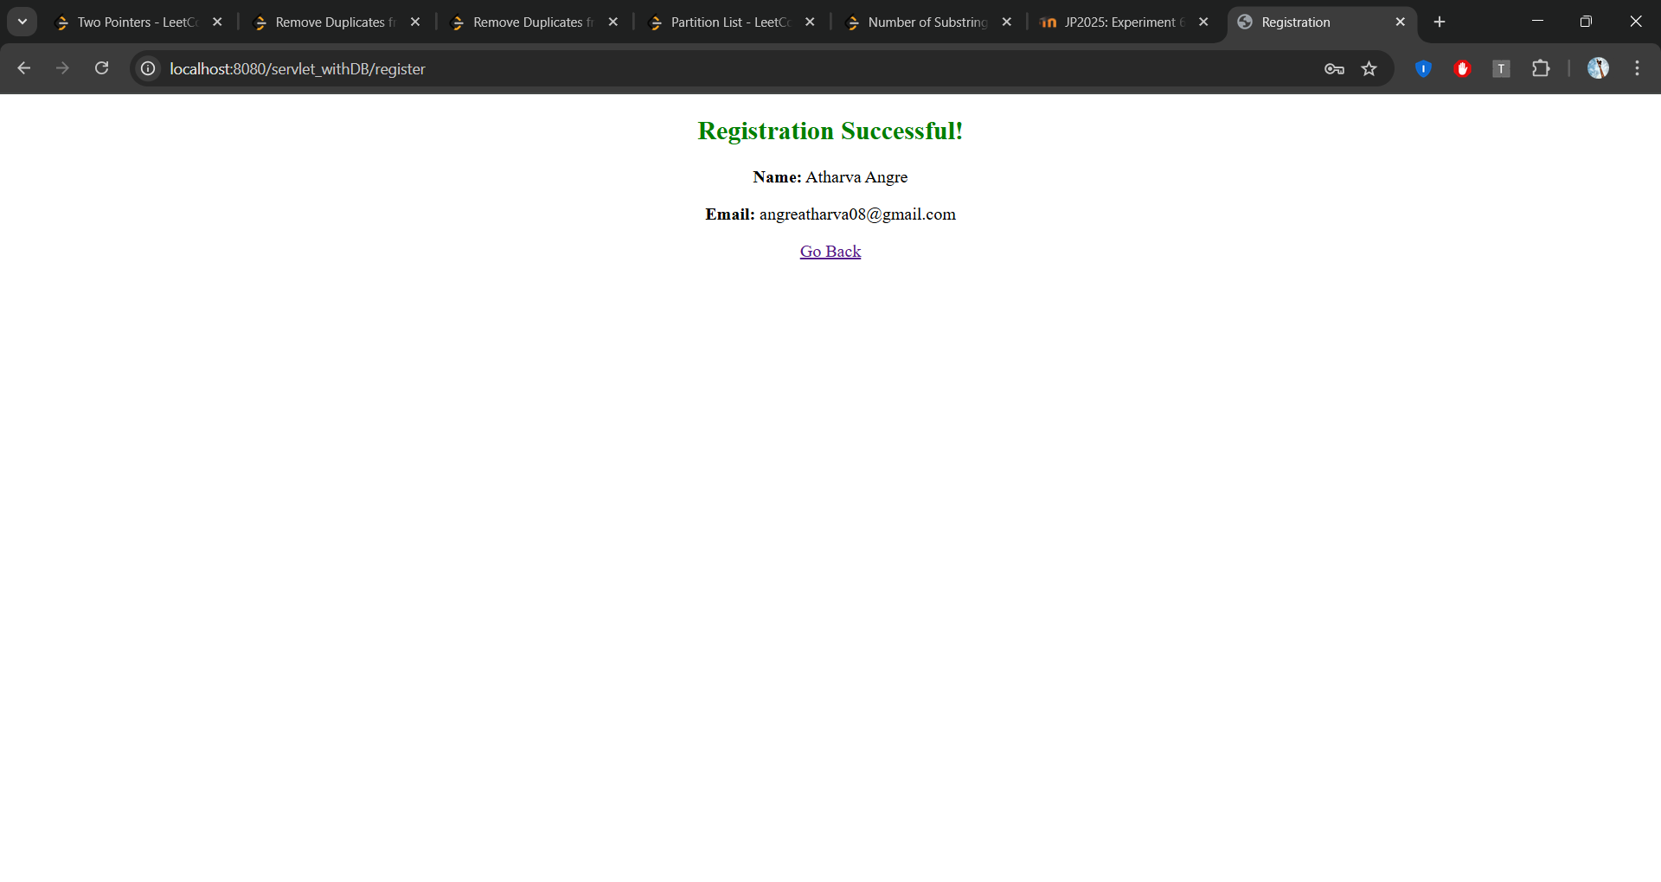

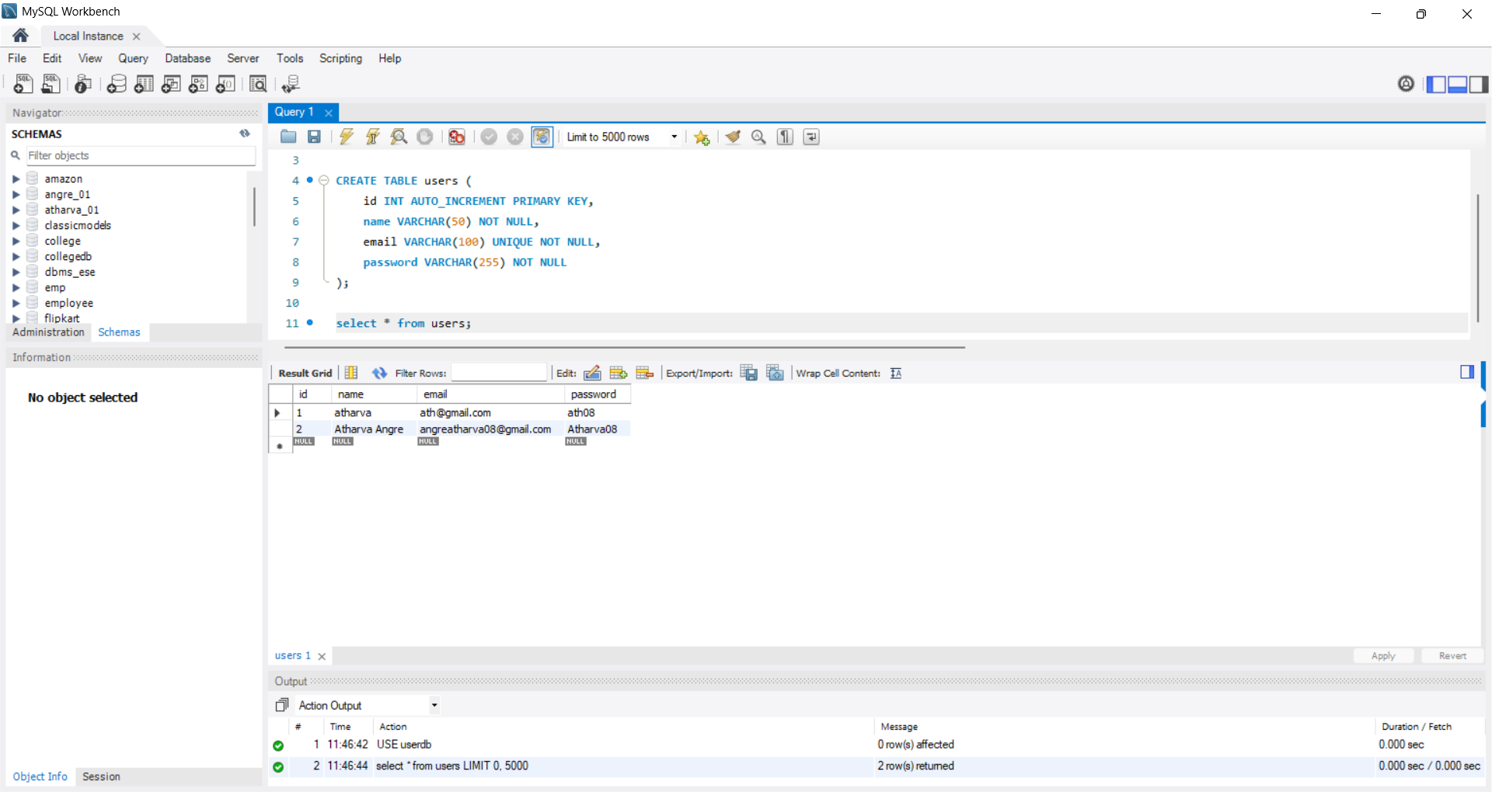

Observation:

Servlets handle client requests and responses dynamically, enabling user registration without a database. JSP simplifies web page creation by combining Java with HTML. Proper request handling ensures smooth interaction and a better user experience.